OTA DFU: Nordic nRF52832
Author: Md Rafi Islam
This is the documentation which will describe the steps to be followed for wireless DFU.

Requirements:
- nRF Connect for Mobile installed in phone.

DFU from Mobile App (nRF connect)
- Download the ‘ble_app_uart_pca10040_s132.zip’ to your phone. You can send the zip file as an email attachment and download in your mobile.
- From “nRF Connect for Mobile,” search and connect to the ‘AIM21’. Click on “Nordic UART Service” and then click on the “RX characteristics” that has upper arrowhead symbol.
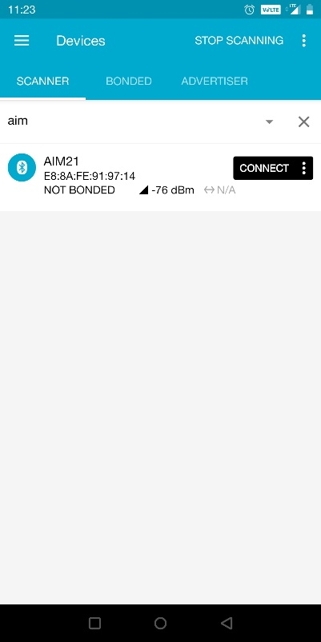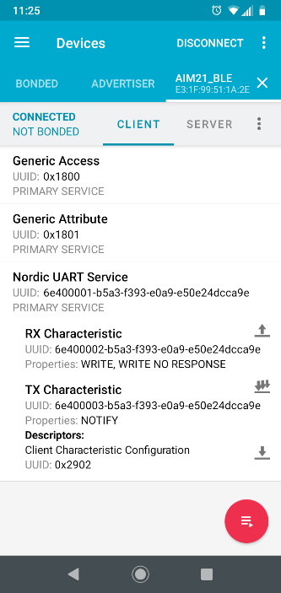

- Click on “BYTE” dropdown menue and select “TEXT.” In the “New value field, write “STARTDFU” and press “SEND.”
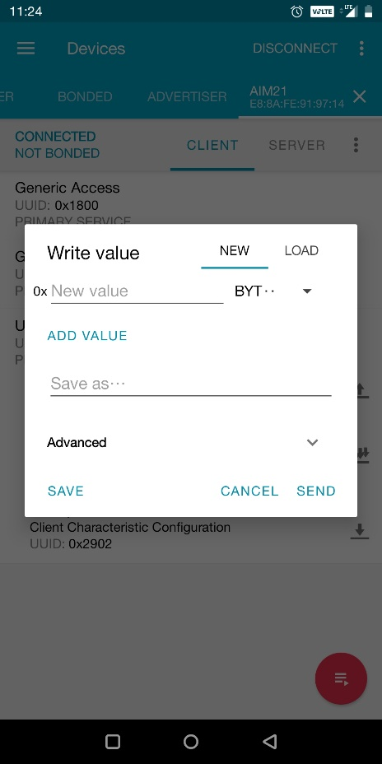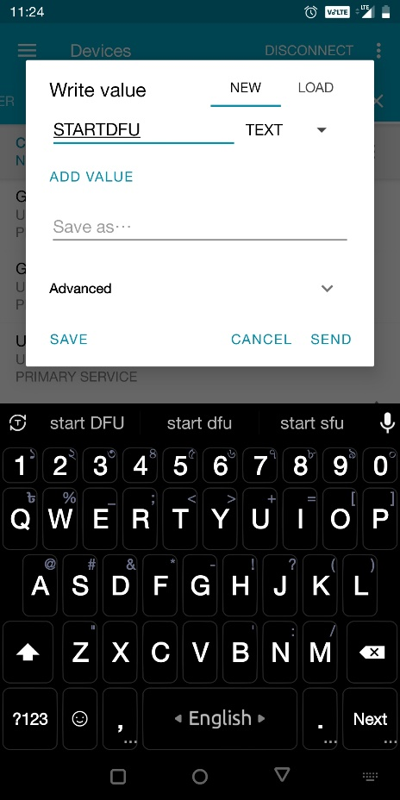
- Now, go to “SCANNER” tab of the nRF Connect application and click on “SCAN” on the top write corner of the screen. Connect to “DfuTarg” and click the circular DFU icon on top right corner of the DFU_Targ tab. Click on “Distribution packet (ZIP)” and click “OK.”
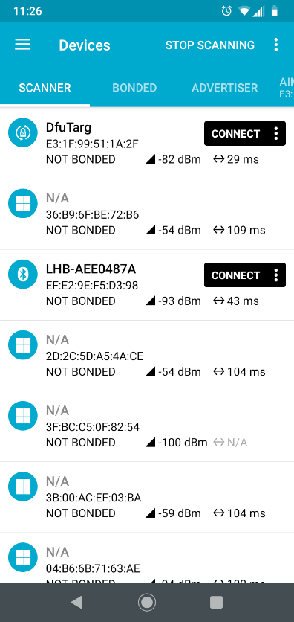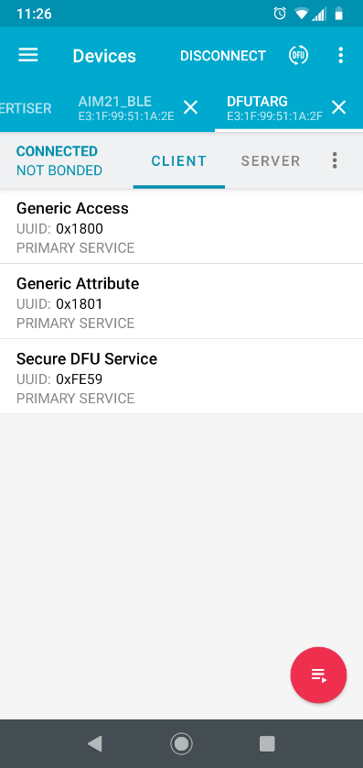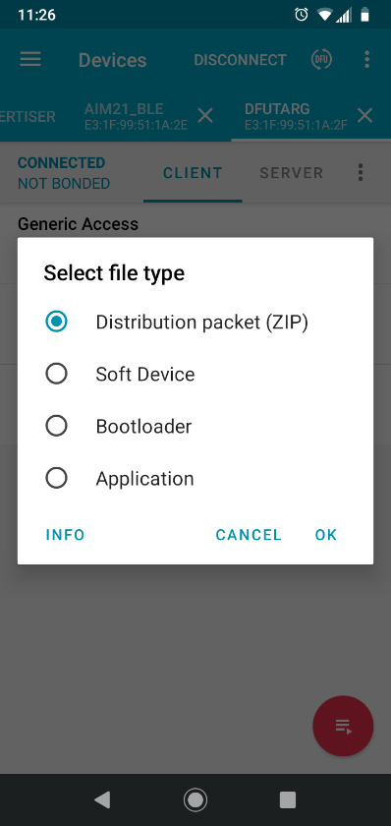

- Select the “ble_app_uart_pca10040_s132.zip” file and wait till 100% uploading is completed. When it is done, it’ll advertise as AIM21_BLE.


